Software Design Document

For Minor Project

POORNIMA PAYMENTS



|  |  |  |  |
| --- | --- | --- | --- |
| Prepared by:  Aditya Laxkar  (PCE15IT003 )  Tushar Gupta  (PCE15IT061) | Guide:  Mr. Shirish Nagar  Asst. Prof. | | |
| Department of Information Technology,  Poornima College of Engineering | | | |
| 22/10/2018 Session – 2018-19 | | | |
| Table of Contents | | Page No. |
| 1. Introduction | | III |
| **2. Architectural Design (System Flow Chart,)** | | IV |
| **3. UML Diagram (Class Diagram, Deployment Diagram,**  **Package Diagram (optional)** | | V-VII |
| **4. Database Diagrams** | | VIII |
| 5. GUI Design | | IX |
| 6. API Specification  7. Glossary | | X |
| 8. Appendices | | XII |
| 9. References | | XII |
| 10. Guide’s Comments | | XII |

# Introduction

## Purpose

Purpose of creating this application is to take one step further towards digital marketing as by doing digital transaction we can reduce the baggage of carrying paper currency instead of using digital way of payment.

Also it will be helpful for users to keep track of their monthly expenses. This application will also provide some benefits like coupons, offers, %off on purchase, extra benefits.

* 1. **Feasibility**
  + Reliability: The solution should operate with minimum fault in normal condition as well as withstand unexpected circumstances. This criterion is very important due to its link to finance and the distrust of the customers for the new payment method.
  + Security: The solution relates to the protection of payment details and customers’ identity besides preventing business fraud to happen. In short, it should cover the issues of anonymity, privacy and non-repudiation
  + Speed of payment process: The speed of payment process has to be very fast as the customer could not wait patiently for a micro payment transaction and get frustrated with delay.
  + Social acceptability: The new payment process could highly be affected by the market acceptance which mostly comes from public’s prior knowledge and previous experiences with existing mobile payment method.
* In INDIA, mobile payment based on premium SMS has been widely implemented and used in the private companies. It inevitably gives premium SMS method the edge over other competing methods in public opinions

1. **Architectural Design**

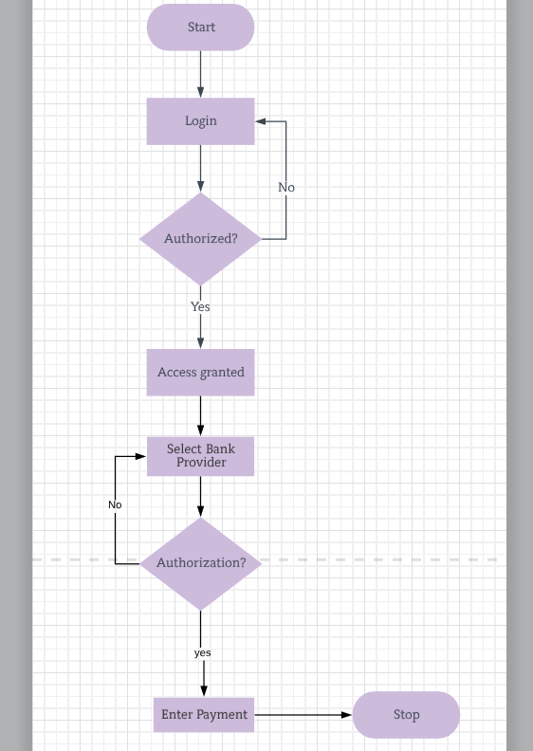

1. **UML Diagram**
   1. **Class Diagram**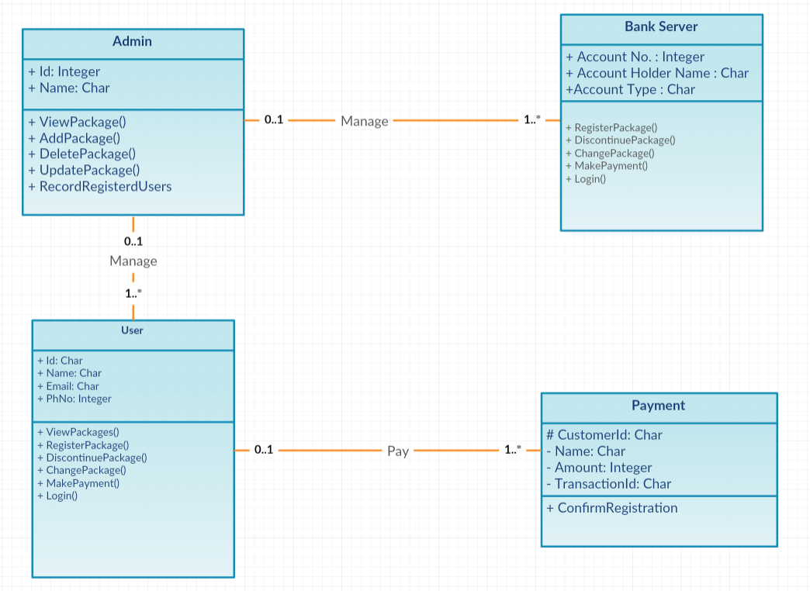
   2. **Deployment Diagram**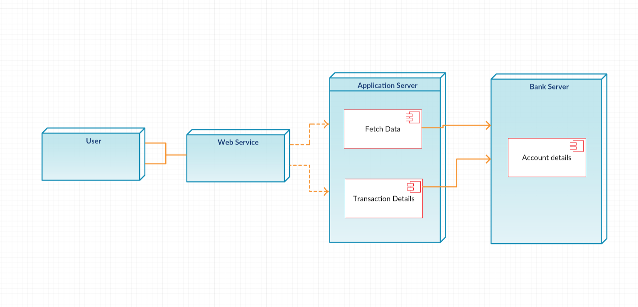

**3.3 Package Diagram**

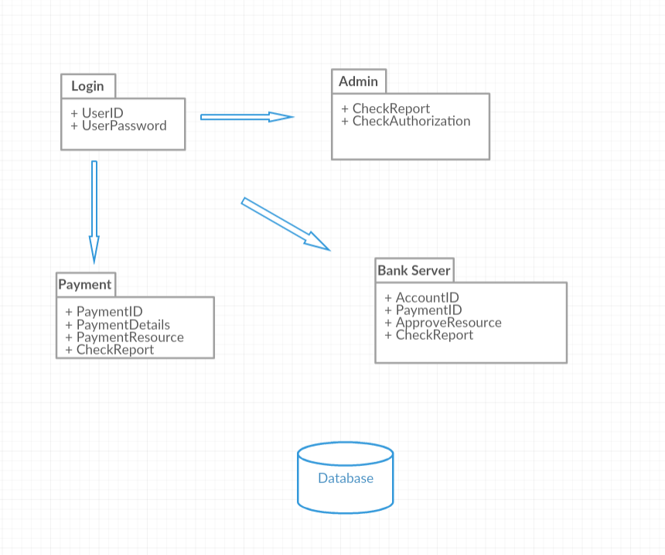

1. **Databases Diagram**

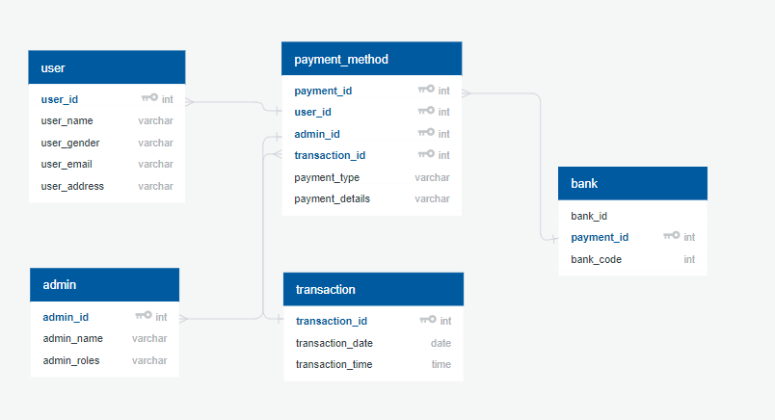

1. **GUI Design**

In this page user login to E-wallet application if user already have existing account in the application. Otherwise user will go to new user activity and then create new user account by fill all the required information.

Otherwise user have an existing account on the application but user forget their user login account password then user can go to forget password page and then by giving their username and can change their account password and can again login to the E-wallet application.

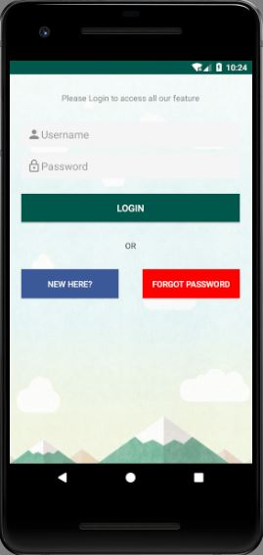

Fig 1:Login Page

In this page user create new user account by fill all the required information. Like name, mobile number, email address, password and confirming that password, user gender then finally click on sign up button and user account will be automatically created in the E-wallet application and next time when user want to use this E-wallet application then user have to only login the E-wallet application and no need of creating new account every time user want to use this application.

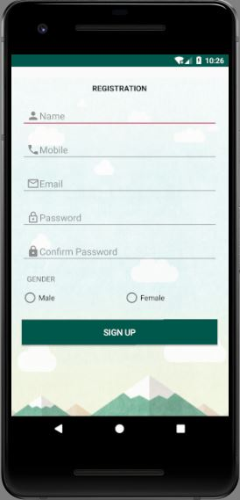

Fig 2: Account Creation page

In this page already existing user can change their account password if they forget their account password and user wishes to continue using application using that same account then user can reset their account password if they forget their account password.

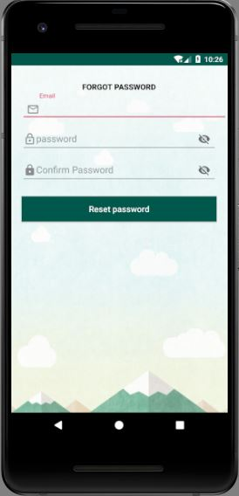

Fig 3: Forget password

In this page user will be able to check its account profile details like its username QR-Code, contact number, Help, guidelines, terms and conditions of the E-wallet application.

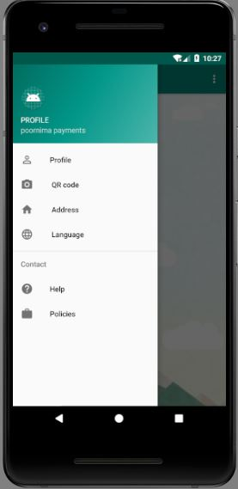

Fig 5: user Profile Page

1. **API Specification**

**7. Glossary**

**8. Appendices**

**9. References**

* http://developer.android.com/reference/android/hardware/Camera.html
* http://developer.android.com/guide/topics/location/index.html
* Reference: http://code.google.com/apis/maps/documentation/places/
* Reference: <https://www.x.com/community/ppx/dev-tools>
* <https://sachinsdate.wordpress.com/2013/04/27/non-functional-requirements-in-mobile-applications/>
* www.stackoverflow.org

**10. Guide’s Comments:**